# Dead Lock:

**Dead Lock is a situation , where more than one thread is depending on each other in circular dependency.**

**In java applications, once we are getting deadlock then program will be stucked in middle, so that, it will not have any recovery mechanisms, it will have only prevention mechanisms and once deadlock is occurred we are unable to do anything for that.At max we may just avoid the deadlock situations.**

**Coding Example:**

class Register_Course extends Thread

{

Object course_Name;

Object faculty_Name;

Register_Course(Object course_Name, Object faculty_Name)

{

this.course_Name=course_Name;

this.faculty_Name=faculty_Name;

}

public void run()

{

synchronized(course_Name)

{

System.out.println("Register_Course Thread holds course_Name resource and waiting for faculty_Name resource.....");

synchronized(faculty_Name)

{

System.out.println("Register_Course is success, because,

Register_Course thread holds both course_Name and faculty_Name resources");

}

}

}

}

class Cancel_Course extends Thread

{

Object course_Name;

Object faculty_Name;

Cancel_Course(Object course_Name, Object faculty_Name)

{

this.course_Name=course_Name;

this.faculty_Name=faculty_Name;

}

public void run()

{

synchronized(faculty_Name)

{

System.out.println("Cancel_Course Thread holds faculty_Name resource and waiting for course_Name resource.....");

synchronized(course_Name)

{

System.out.println("Cancel_Course is success, because,

Cancel_Course thread holds both faculty_Name and course_Name resources");

}

}

}

}

class Test

{

public static void main(String[] args)

{

Object course_Name=new Object();

Object faculty_Name=new Object();

Register_Course registercourse=new Register_Course(course_Name, faculty_Name);

Cancel_Course cancelcourse=new Cancel_Course(course_Name, faculty_Name);

registercourse.start();

cancelcourse.start();

}

}

**Note:Both are depending on each other for their resources. So here, deadlock situation will occur. When deadlock situation is identified, automatically program is available in stucked mode.**

**Assignment:**

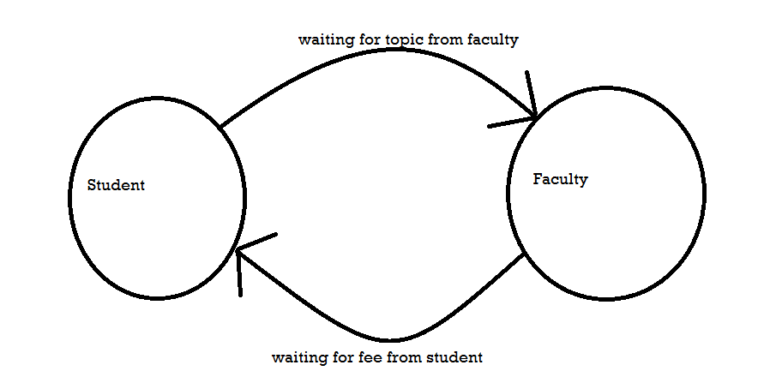

**Implement the above deadlock situation in the code.**